1. **What are comments and what is the importance if commenting in any code?**

A comment is text in a program's code, script, or another file that is not meant to be seen by the user running the program. However, is seen when viewing the [source code](https://www.computerhope.com/jargon/s/source.htm). Comments help make code easier to understand by explaining what is happening and help prevent portions of a program from executing. The image is an example of an [HTML comment](https://www.computerhope.com/jargon/h/html-comment.htm). See our [nonexecutable statement](https://www.computerhope.com/jargon/n/nonexecu.htm) page for a full definition and further examples of comments in programming.

1. **What is Call Statement and when do you use this statement?**

**Call Statement**

This statement calls another application.This statement has the following syntax:

**call***subsystem*([*parametername* **=** *value*  
     {**,** *parametername* **=** *value*}]**);**

The call statement specifies optional parameters that call another application. This call blocks all frames in the OpenROAD application until the user exits from the called subsystem. When the user exits from the subsystem, the application resumes execution with the statement following the call statement.If you issue the call statement in a transaction, the statement commits the transaction without a warning message before invoking the subsystem. To ensure data integrity, if a transaction is open, terminate it before issuing the call statement.

1. **How do you compile a code in VBA? What are some of the problem that you might face when you don’t compile a code?**

A compile error for a missing “End if” part of an IF statement. Every individual line in the code is correct, but together, they don’t represent a complete IF statement.

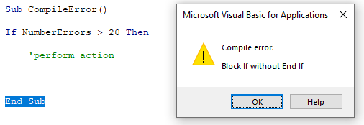

**4. What are hot keys in VBA? How can you create your own hot keys?**

To create a macro and assign a keyboard shortcut:

1. Open the file you want to use or create a new workbook.
2. Click the View tab in the Ribbon.
3. Click Macros and select Record Macro. A dialog box appears.
4. Under Macro Name, name the macro (no more than 255 characters and do not include spaces or begin with a number or an underscore).
5. Under Shortcut key, enter a keyboard shortcut. For example, type Shift + H (this would assign Control + Shift + H as the shortcut). By adding Shift, you are less likely to create the same shortcut as a built-in Excel shortcut.
6. Under Store macro in, choose This Workbook, New Workbook or Personal Macro Workbook. For global shortcuts, save the macro in the Personal Macro Workbook which is launched on startup and is hidden by default. If you store a macro in another workbook, it will need to be open to run the macro.
7. Under Description, you can enter a description.
8. Click OK.

**5. Create a macro and shortcut key to find the square root of the following numbers 665, 89, 72, 86, 48, 32, 569, 7521**

To use this function, type the term =SQRT and hit the tab key, which will bring up the SQRT function. Moreover, this function accepts a single argument. read more in both Excel and VBA. The method to use this function is SQR(Number).

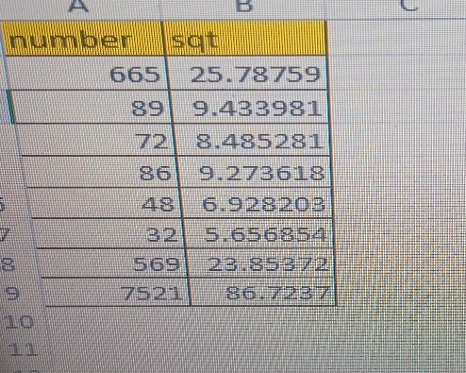

**6. What are the shortcut keys used to**

**a. Run the code**

press Alt+F8 to open the "Macro" dialog. Then select the wanted macro from the "Macro Name" list and click the "Run" button

**b. Step into the code**

You can do this by either pressing the F8 key or selecting "Step Into" under the Debug menu.

**c. Step out of code**

Stepping Out of Code : CTRL + SHIFT + F8

**d. Reset the code**

Press Alt + F11 keys simultaneously, and a Microsoft Visual Basic for Applications window pops.